
Remove this

Should be in one line

Headline should be ‘Indian Origin Products’ . Lower line should be in one line. Align entire thing in centre.
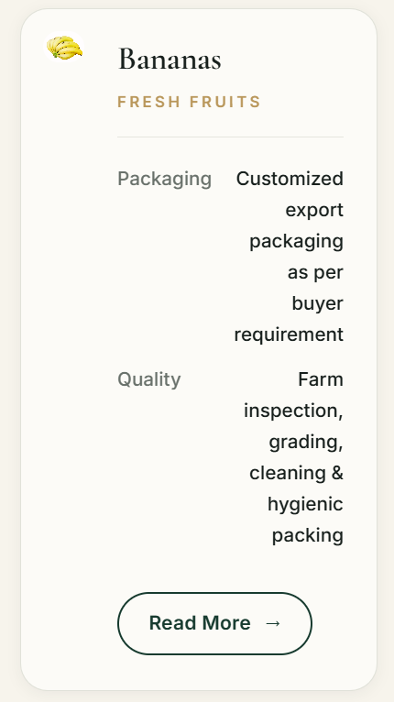
Align the image in centre and make it biger slidable images where we can add at least 10 images as you did in homepage products section. Write Specifications instead of fresh fruits. Then make two colums like:
Slidable Images (10 images)
Banana
Specifications
Border
Variety | G9 Cavendish
Grade | Super Premium
Maturity | 70-80% Mature Green
Colour | Green/Dark Green
Fruit Legnth | 18-25 cm
Hands | 4, 5, 6, 7
Box | 5 Ply Box-3 Ply Lid, All aroud 5 Ply
Box Dimentions | 500 x 300 x 200 mm
Sachets | Ethylene Absorbent Small Packets
Brand | Brand Sticker
Rubber Band | To seal liner bags
Air Remove | Vacume/Manual
Get A Quote Button Read More Button

Should be aligned in centre. Change Headline as ‘Imported Products’. Then write down:
We Import Dry Fruits and process it in our world class processing units, repack it and re-export to various destinations and distribute in PAN India domestic market as well. Our Imported products are: (Don’t shrink it’s width, let it be spread in full screen.)
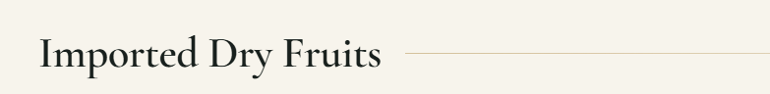
just write ‘Dry Fruits’
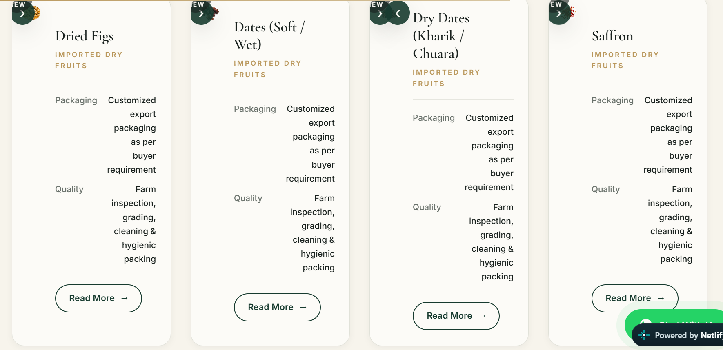
Both Dates colums should come first in dry fruits section.
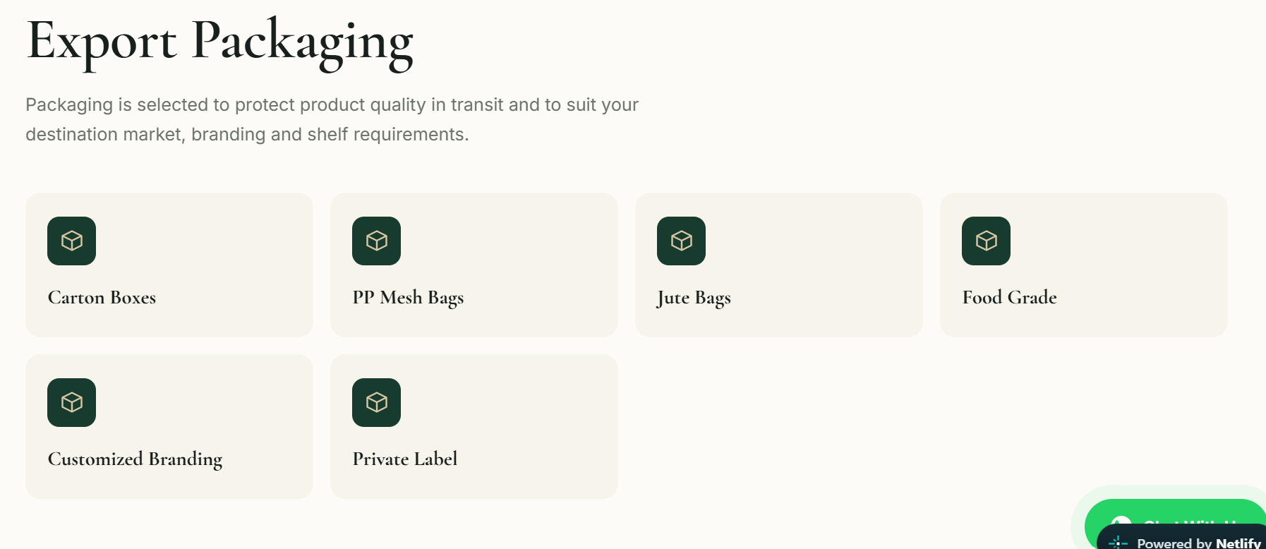
Make the headline and it’s details as I instructed for previour sections. Put all 6 points in just 1 row.
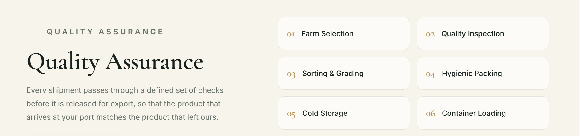
Bring headline and it’s detail up and align as previously instructed. Bring points section down in just 1 row.

Create separate section for this.
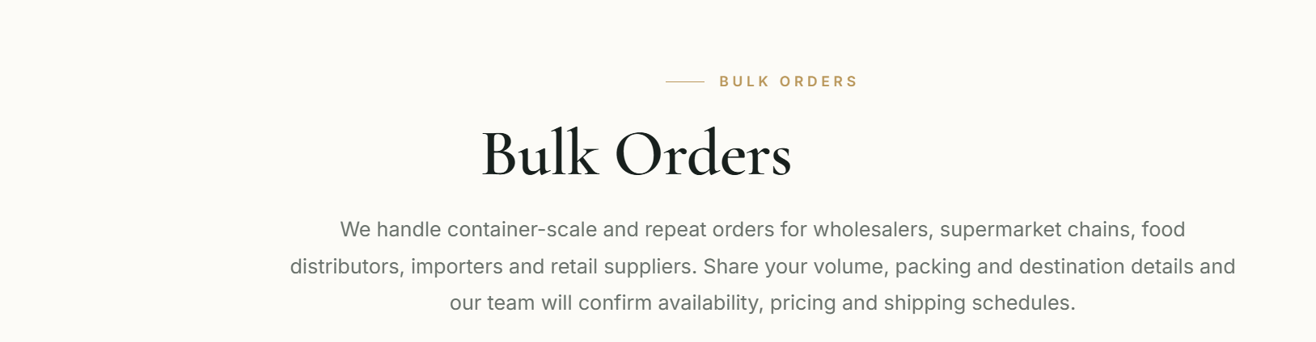
Please remove this section.

